

www.mes-english.com

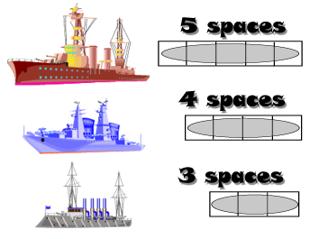

1. Draw in 2 of each boat in your ocean.
(6 ships total)
2. Attack enemy ships by calling a square
( Did you play soccer yesterday? )
3. Sink all the enemy ships to win



 | play | watch | use | go | read | get | come | have | study
yesterday
Tuesday
last week
last year
Monday
Wednesday
this morning |  |  |  | www.mes-english.com


 | play | watch | use | go | read | get | come | have | study
yesterday
Tuesday
last week
last year
Monday
Wednesday
this morning |  |  |  | www.mes-english.com

