

www.mes-english.com

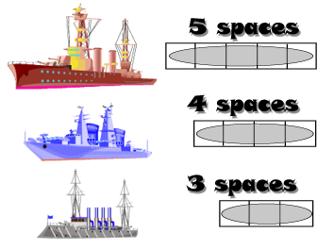

1. Draw in 2 of each boat in your ocean.
(6 ships total)
2. Attack enemy ships by calling a square
( Does Ken play soccer? )
3. Sink all the enemy ships to win



 | eaten | kicked | licked | punched | kissed | loved | hit | hugged | run over
Doraemon

Pikachu
Snoopy
H. Kitty
Pooh
Maruko
Miffy |  |  |  | www.mes-english.com
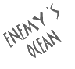

 | eaten | kicked | licked | punched | kissed | loved | hit | hugged | run over
Doraemon

Pikachu
Snoopy
H. Kitty
Pooh
Maruko
Miffy |  |  |  | www.mes-english.com

