

www.mes-english.com

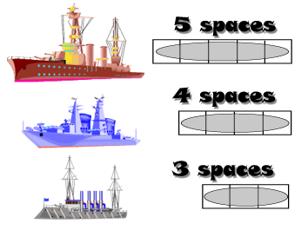

1. Draw in 2 of each boat in your ocean.
(6 ships total)
2. Attack enemy ships by calling a square
( Does Ken play soccer? )
3. Sink all the enemy ships to win



 | play | watch | read | listen | like | study | go | cook | make
Ken
Sara
Yumi
you
Emi
Taro
Mark |  |  |  | www.mes-english.com
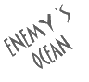

 | play | watch | read | listen | like | study | go | cook | make
Ken
Sara
Yumi
you
Emi
Taro
Mark |  |  |  | www.mes-english.com

