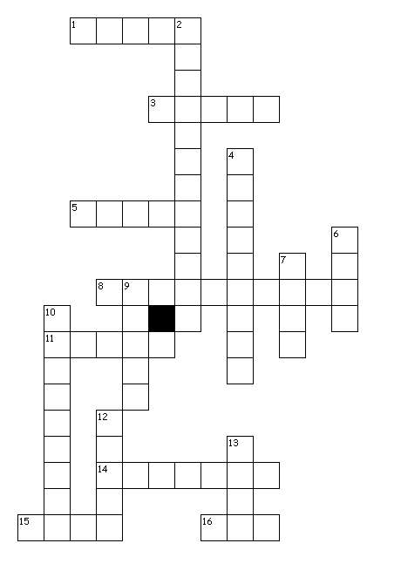
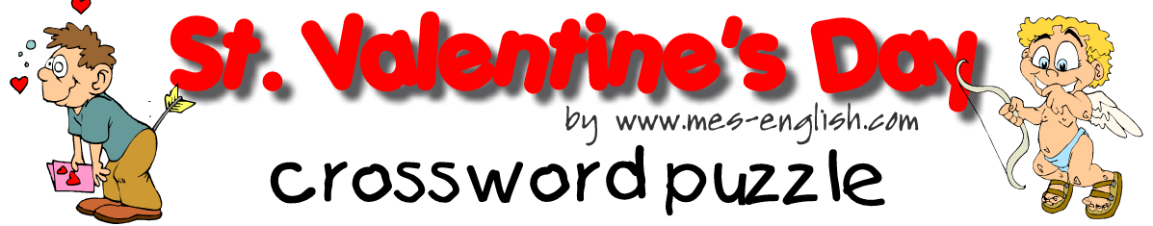
MES-English.com ESL/EFL Resources for Teachers of Young Learners
Happy Valentine’s Day
Happy Valentine’s Day

Across:
1. Before we send a valentine
3. Small hearts are made of this.
5. Something you don't like is ____ .
8. These are beautiful flowers.
11. It's given away.
14. Someone who gets a lot of valentines is ____ .
15. After we write a valentine
16. On Valentine's Day we ____ a valentine.

Down:
2. Giving a valentine is ___ .
4. The card we write
6. A flower with thorns
7. The reason we celebrate
Valentine's Day.
9. Cupid's weapon
10. It's in the box.
12. He brings love.
13. Two people going out

Answers:

heart - it's given away
valentine - the card we write
chocolate - it's in the box
candy - small hearts are made of this
cupid – He brings love
arrow - Cupid's weapon
date - two people going out
write - before we send a valentine
send - after we write a valentine
get - on Valentine's Day we ____ a valentine
popular - someone who gets a lot of valentines is
gross - something you don't like is
embarrassing - giving a valentine is
carnations - these are beautiful flowers
love - the reason we celebrate Valentine's Day
rose - a flower with thorns

