www.mes-english.com

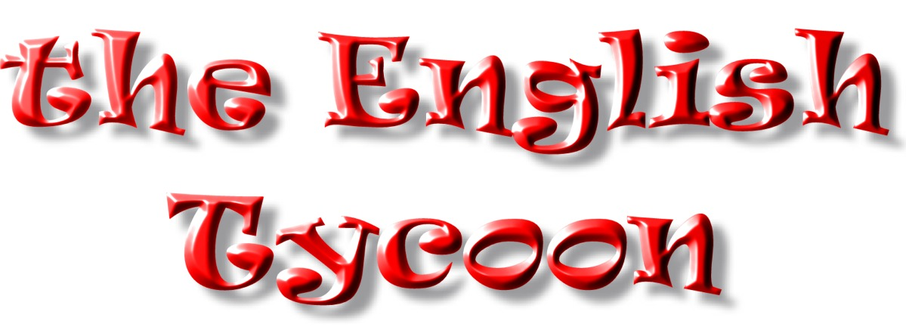

Each time you land on A, B, or C you must complete the following or pay a $1 fine to the bank. Here are today’s sentences:

A: He is going to play the piano tomorrow.

B: He isn’t going to play the piano tonight.

C: Is he going to play the piano after class?

Let’s practice a little. Try making these:

A:

B:

C:

A:

B:

C:

Here are some useful phrases for playing the game:

I would like to buy this property. Who owns this property?

How much is it? Would you like to trade ~ for ~ ?

How much is the rent? Can I buy ~ from you?

You owe me $3. Here is the rent I owe you.

I need some money. I would like to mortgage this property.

マークの英会話教室

