
Try to get four squares in a row by calling a square and writing in your mark.

Example: He has a cough and a cold

 | a cold | a fever | a sunburn | a headache | sore eyes
a cough
a sore throat
a backache
sore muscles
a toothache

 | Vancouver | San Francisco | Honolulu | Saku | Tokyo
Nagoya
Beijing
London
Hong Kong
Paris

 | a cold | a fever | a sunburn | a headache | sore eyes
a cough
a sore throat
a backache
sore muscles
a toothache

 | Vancouver | San Francisco | Honolulu | Saku | Tokyo
Nagoya
Beijing
London
Hong Kong
Paris
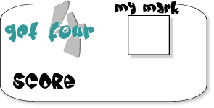

MES-English.com ESL/EFL Resources for Teachers www.mes-english.com
©2020 MES-English.com ESL/EFL Resources for Teachers

