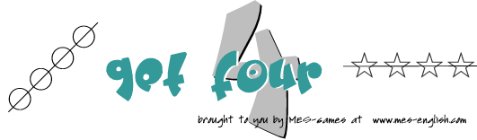
Try to get four squares in a row by calling a square and writing in your mark.
Example: I have studied English for 2 years.
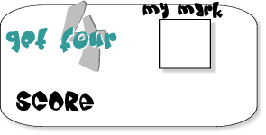

 | for 2 years | since 1999 | for a long time | for many years | since yesterday | never | for one week | since December | Have you ~? | How long have you? | for many years | for 1 month
study English
play the piano
live in Canada
study cooking
be in/to England
watch that TV show
be their fan
want a car
play volleyball
be in school
need a new coat
play soccer

©2020 MES-English.com ESL/EFL Resources for Teachers www.mes-english.com

